|  |
| --- |
| Name: A.V.Rajapaksha |
| Student Reference Number: 10638355 |



|  |  |  |
| --- | --- | --- |
| Module Code: PUSL2008 | Module Name: Introduction to Internet of Things | |
| Coursework Title: IOT Project | | |
| Deadline Date: 06-05-2019 | | Member of staff responsible for coursework: Dr. Chandana Perera |
| Programme: Bsc(hons) Software engineering | | |
| Please note that University Academic Regulations are available under Rules and Regulations on the University website [www.plymouth.ac.uk/studenthandbook](http://www.plymouth.ac.uk/studenthandbook). | | |
| Group work: please list all names of all participants formally associated with this work and state whether the work was undertaken alone or as part of a team. Please note you may be required to identify individual responsibility for component parts.  S.B.W. Kavindu Weerasuriya-10640380  A.V. Rajapaskse-10638355  W.A.P.C. Rupasinghe-10638226  D.L.S. Kuruppu-10638323  G.K. Samarasinghe-10638123  ***We confirm that we have read and understood the Plymouth University regulations relating to Assessment Offences and that we are aware of the possible penalties for any breach of these regulations. We confirm that this is the independent work of the group.***  Signed on behalf of the group: | | |
| Individual assignment: ***I confirm that I have read and understood the Plymouth University regulations relating to Assessment Offences and that I am aware of the possible penalties for any breach of these regulations. I confirm that this is my own independent work.***  Signed : | | |
| Use of translation software: failure to declare that translation software or a similar writing aid has been used will be treated as an assessment offence.  I *have used/not used translation software.  If used, please state name of software………………………………………………………………… | | |
| **Overall mark _____% Assessors Initials ______ Date_________** | | |

*Please delete as appropriateSci/ps/d:/students/cwkfrontcover/2013/14

**CONTENT**

* Acknowledgement
* Introduction to IOT
* Objective
* Problem Statement
* Circuit Design
* Arduino Source Code
* External view
* Required devices
* App interface
* Conclusion

**Acknowledgement**

First of all, it is our duty to salute our dearest NSBM staff. Since we are the beginners to the field the guidelines and the instructions given by our dear sir, Dr. Chandana Perera, A Lecturer in NSBM is unforgettable and excellent. We convey our sincere thanks to you sir.

The task was not easy to all of us. But it is our pleasure to submit this as a combined effort with all suggestions and criticisms of our team members. All were got together to have a good end. Finally, we achieved it. Here we thank each and every member of our team for their fullest cooperation.

Finally, we do hereby extend our sincere thanks to those who helped us directly as well as indirectly to fulfill our target.

**Introduction to IOT**

Green environment has become a very vital and enthusiastic concept in the present world. Everybody keen to maintain a green surrounding at any point of the earth. Apart from that agricultural and cultivation needs are very vital in present heavy moving society.

Since the workforce in agricultural field is very small and the cost of labour has become very high alternative methods should be introduced to maintain the Green Concept. It is not only limited to the commercial sector but for the home needs also. Most of the people do not have reasonable spare time to look after their home gardens because of their very busy schedules in the life. Watering, fertilizing, maintaining are some of the basic needs that we have to provide to have a nice looking greenish and blooming garden. Lak of time has created a problem in maintaining such environment.

Therefore, some technical and networking methods should be introduced to the society as suitable for their fast-moving lives.

‘SMART’ is one of the most popular word nowadays. Smart concept can be applied even too maintain the good gardening method. SMRAT Watering Concept is one of that methods which can be used for domestic as well as the commercial needs.

**Objective**

The main objective of the project is to introduce and build a hardware in Arduino and create AI application to assist the people in their gardening and agricultural needs.

We built a hardware that can automatically watering to plants. So, we can use this project when we are in busy times.

Also, we use an application which can be used by the civilians on their smart devices such as phones and tabs to watering their domestic garden plants.

Key features of the system

• Real Time Monitoring

• Real Time Alerting

• User-Friendly Interface

• Easy to configure.

**Problem Statement**

In our project we just design it to make it work while the user near the project because user’s phone connected to the Wi-Fi module. So, it not connected to the internet. That is the main reason that user can’t use this while he is out of the Wi-Fi signal area.

**Circuit Design**

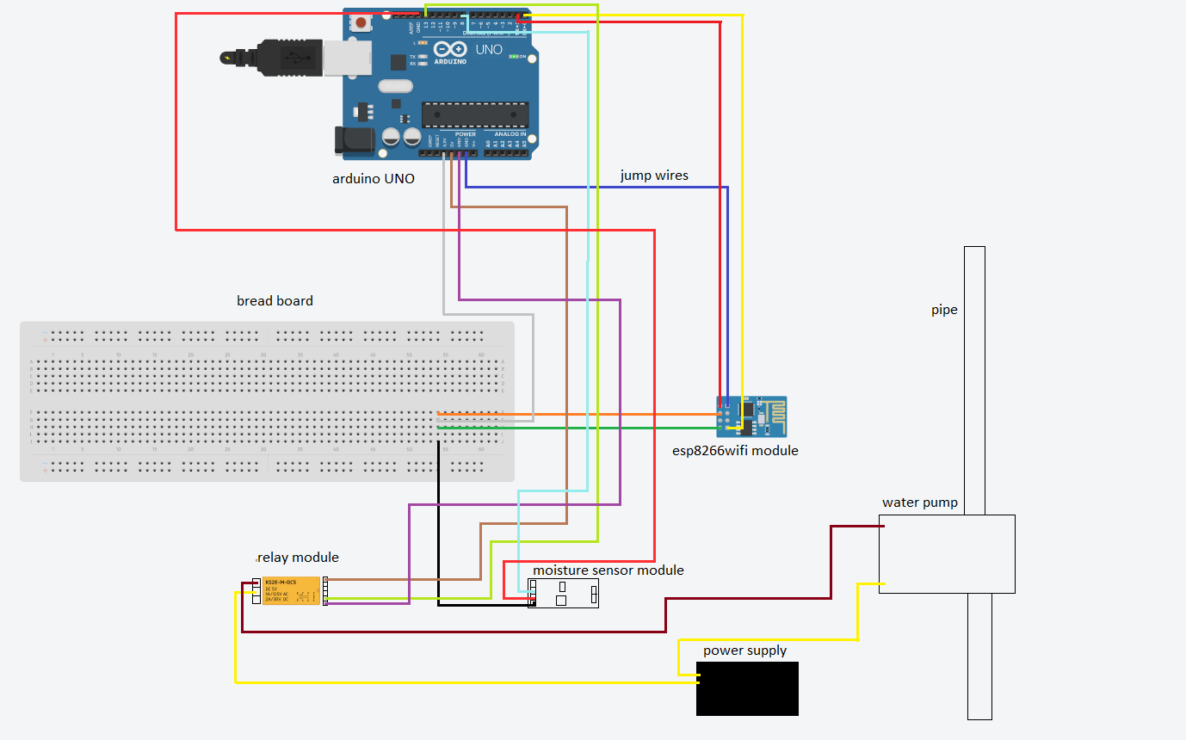

**Arduino Source Code**

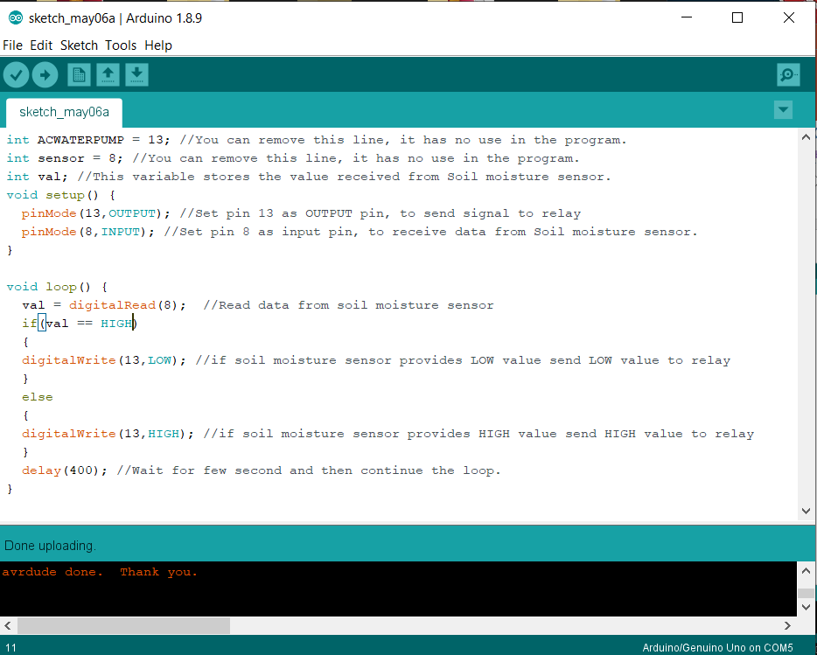

**External view**

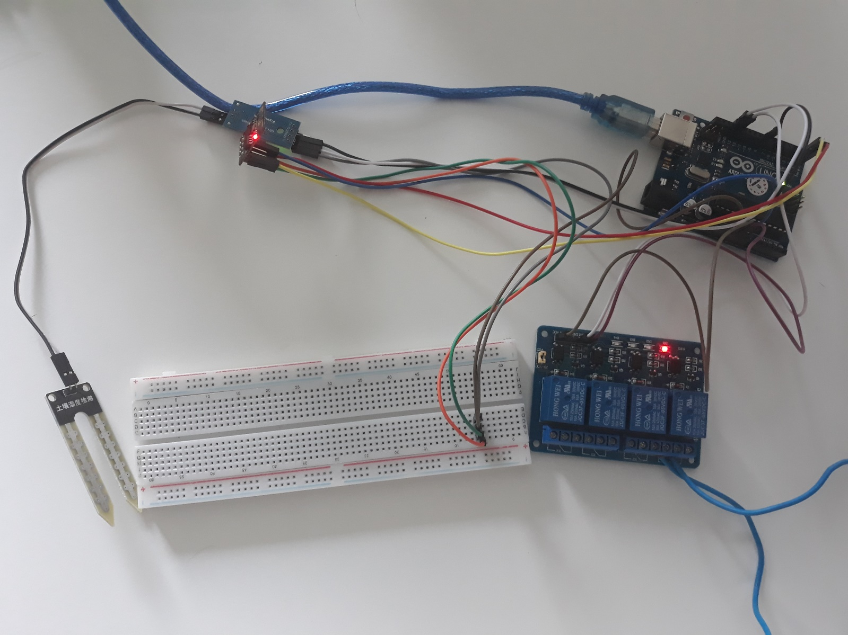

**Required devices**

* Arduino UNO
* ESP8266 WI-FI module
* Soil moisture sensor
* Relay module
* Breadboard
* Jump wires
* Android device

**App interface**

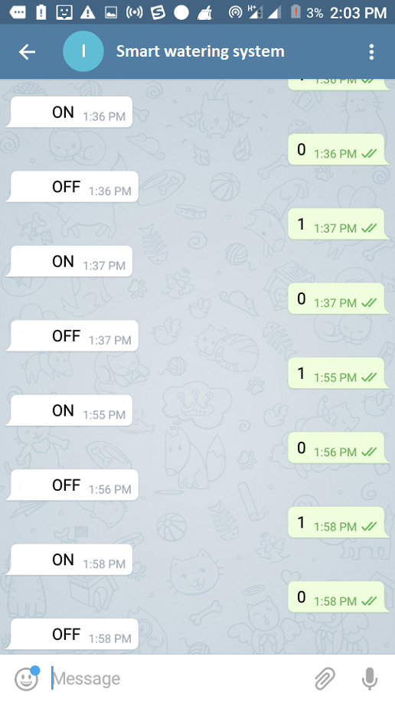

**Conclusion**

Since there are several applications are available in smart devices for the use of customers to make their life very easier this type of application may further make their lives happy.

And the green concept of the world also will become a reality within a very short period of time because the basic needs of planting can be monitor and maintain through such application.

People those who are interested in planting and gardening but do not have a time to spend shall use this application to fulfil their need even during their busy schedule.